**Garage Management System**

**College Name:** HINDUSTHAN COLLEGE OF SCIENCE AND COMMERCE

**College Code:**

**TEAM ID: NM2025TMID28163**

**TEAM MEMBERS:**

* Team Leader Name: PRATIBA.K

Email: pratiba3010@gmail.com

* Team Member1: MADHUMITHA.S

Email: madhumithamadhumitha123456789@gmail.com

* Team Member2: GUGAN.N

Email: gugann546@gmail.com

* Team Member3: SURIYAPRAKASH G

Email: suryagkps3289@gmail.com

**Project Overview**

The Garage Management System is a Salesforce-based CRM solution designed to streamline garage operations. It helps in managing customer details, vehicle information, bookings, services, invoices, and payments efficiently. The system enhances customer engagement, ensures better tracking of services, and automates routine tasks.

**Objective**

This SOP outlines the steps to create and manage a Garage Management System using Salesforce CRM, ensuring all team members can follow the process effectively.

**Key Steps**

1. **Project Overview and Goals**

* Creating Developer Account:

By using this URL - <https://www.salesforce.com/form/developer-signup/?d=pb>

* Activate the account by login to the salesforce developer edition by using developer username and password.

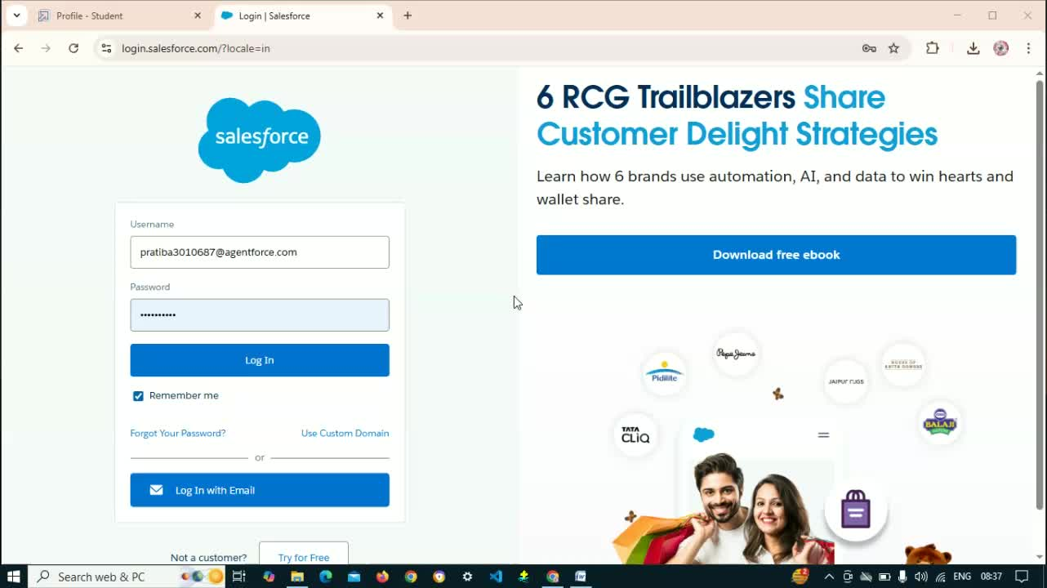

* Introduce the Garage Management System project created using Salesforce CRM.
* Main business goal: Automate garage operations including customer and vehicle management.

**2. Accessing the Application**

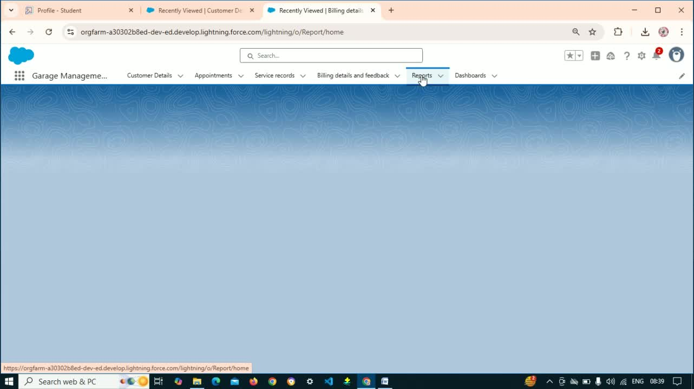

* Navigate to the home page of Salesforce.
* Click on the app launcher and search for the 'Garage Management Application'.

**3. Creating Custom Objects**

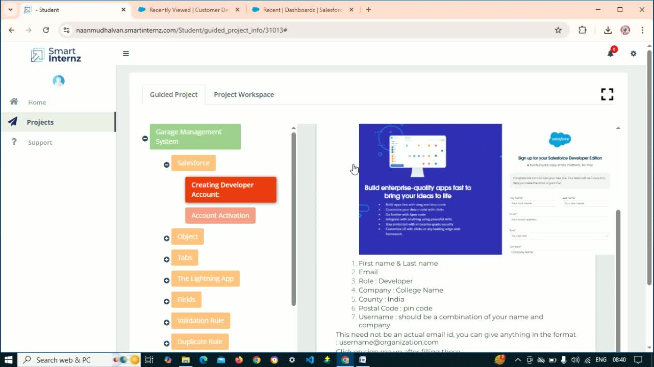

* Open Setup and go to Object Manager.
* Create the following custom objects:
* Customer Details (fields: Name, Phone Number)
  + Appointments (fields: Vehicle Number Plate, Service Amount, Replacement Parts, etc.)
  + Service Records (fields: Quality Check Status, Service Date, etc.)
  + Billing Details and Feedback (fields: Payment Status, Rating, etc.)

**4. Creating Custom Tabs**

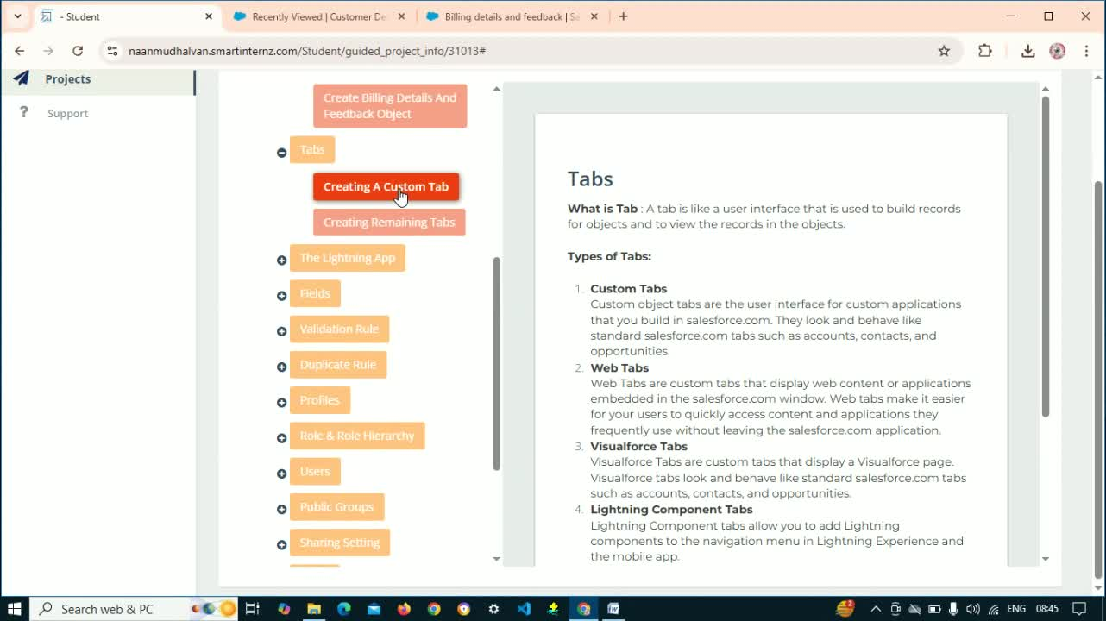

* Use the Quick Find box to create custom tabs for:
  + Customer Details
  + Appointments
  + Service Records
  + Billing Details and Feedback.

**5. Setting Up Lightning App**

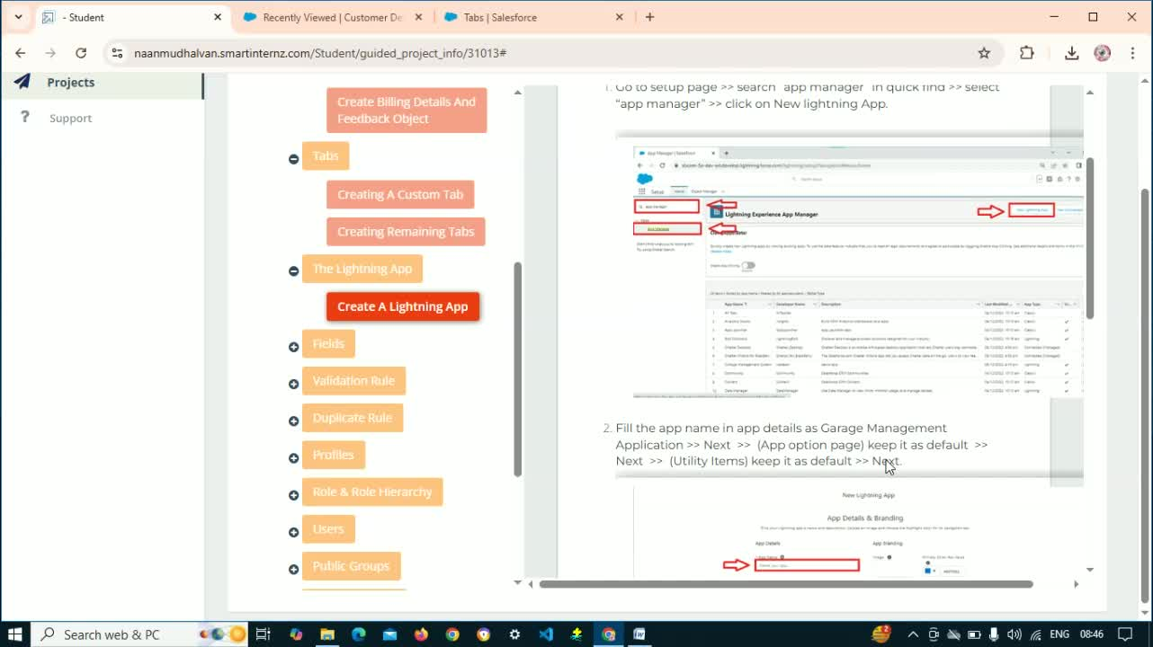

* Create a Lightning App using the Lightning App Manager.
* Include the following in the navigation bar:
  + Customer Details
  + Appointments
  + Service Records
  + Reports and Dashboards.

**6. Creating Fields and Relationships**

* For each custom object, create necessary fields:
  + Lookup Relationships
  + Checkbox, Date, Currency, Text Fields, Picklist Fields, and Formula Fields.

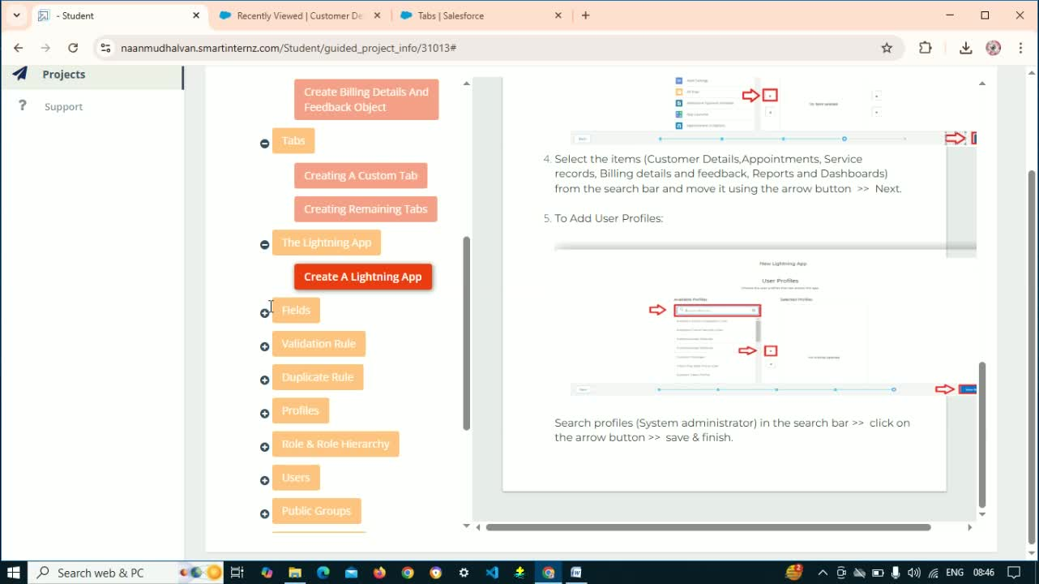

**7. Implementing Validation Rule**

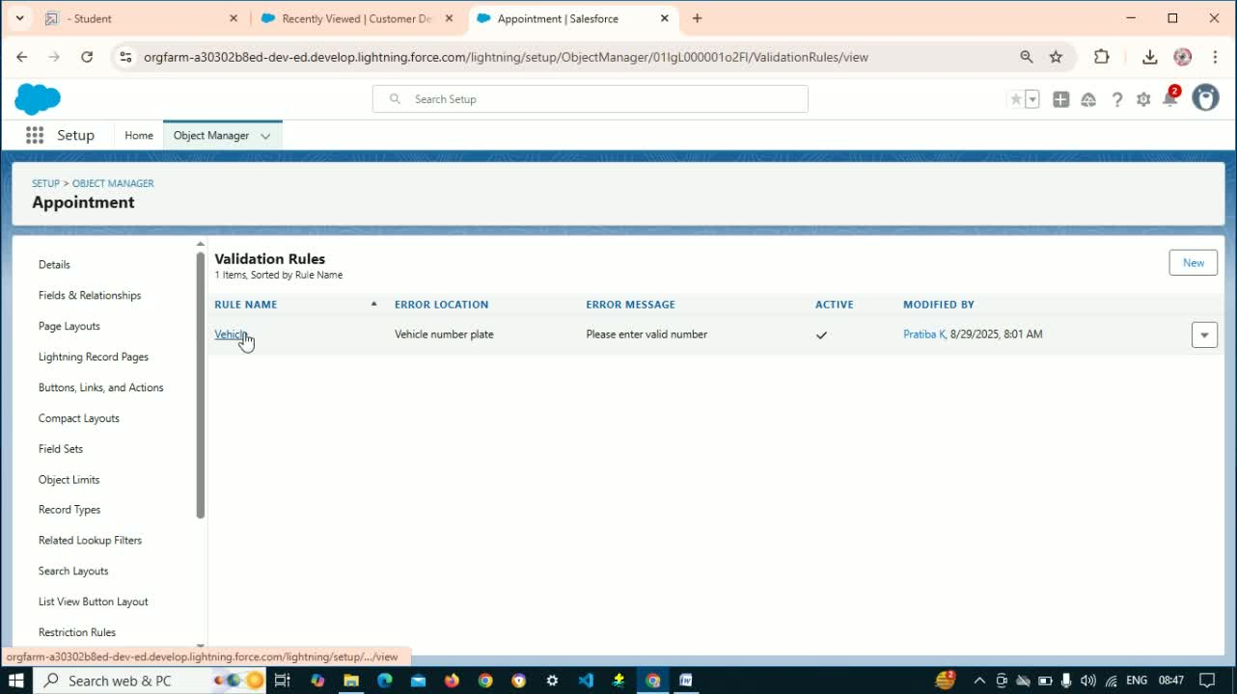

* Create validation rules for:
  + Appointment Object (e.g., Vehicle Number Plate)
  + Building Details
  + Duplicate Rules for Customer Details.

**8. Setting Up User Profiles**

* Create two user profiles:
  + Manager
  + Salesperson (clone from Standard User).

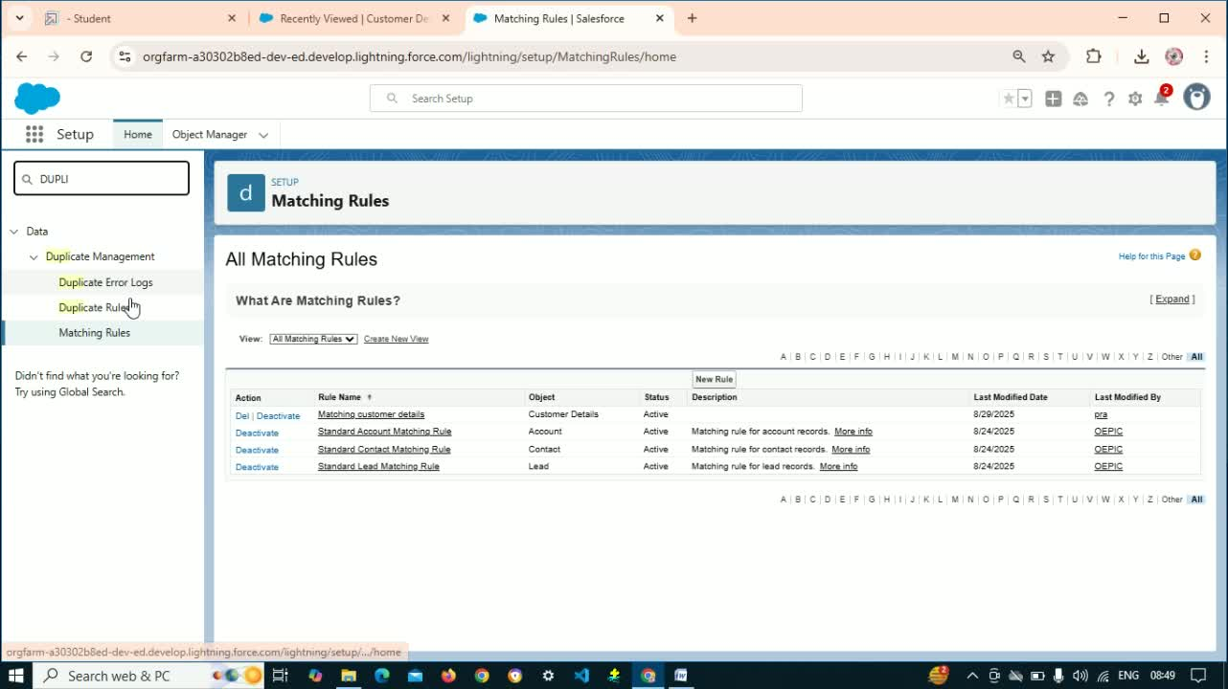

**9. Configuring Role Hierarchy and Users**

* Set up role hierarchy using Setup.
* Create users (e.g., Nicholas, McCullers, Kilson, Michelson).
* Create more users for better experiences .

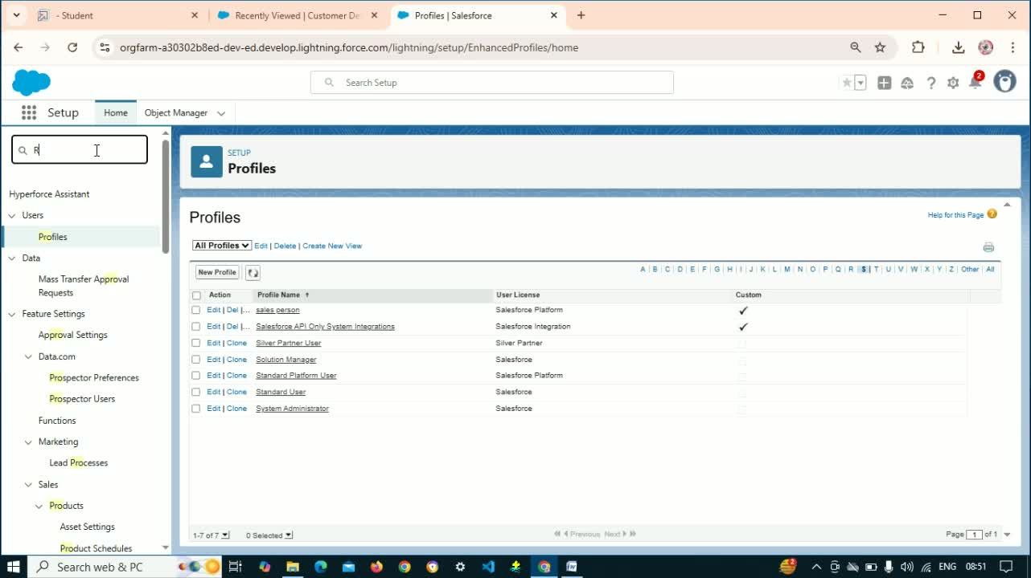

**10. Creating Public Groups**

* Create public groups using the Quick Find box.

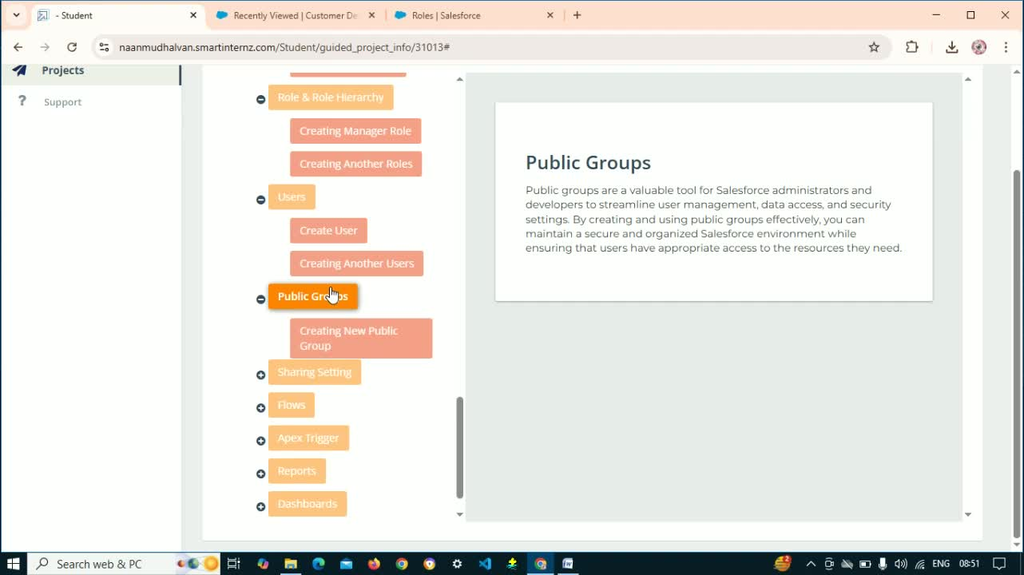

**11. Configuring Sharing Settings**

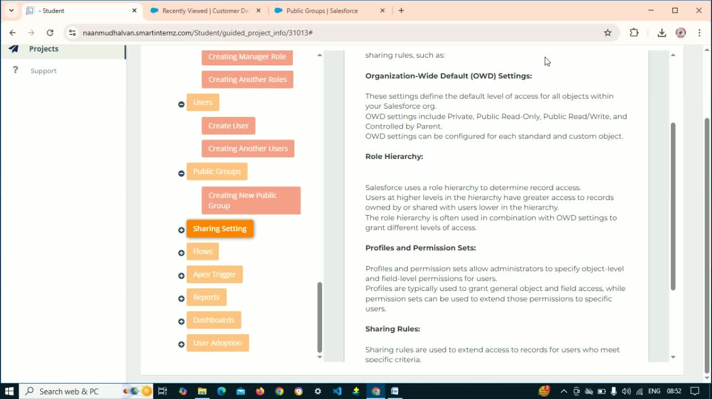

* Configure sharing settings to control record access within the organization.

**12. Creating Flows**

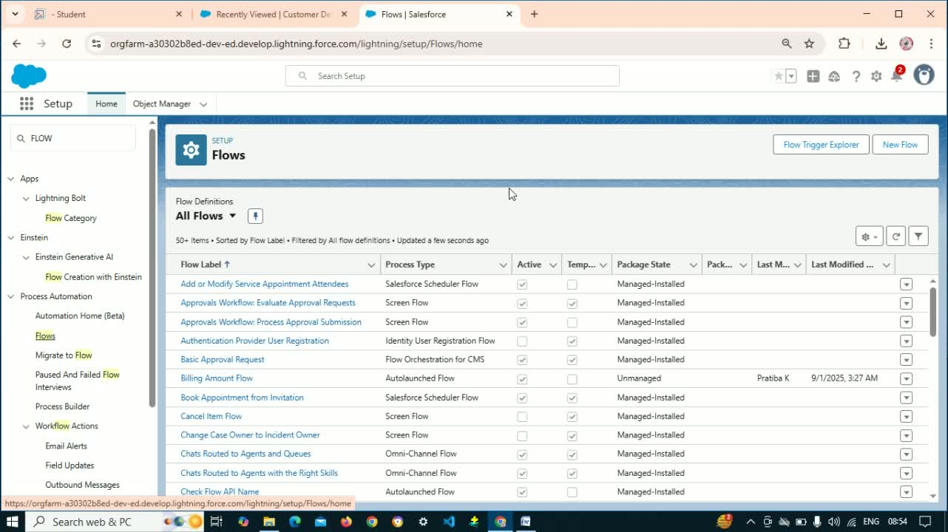

* Create flows for:
  + Email Alerts
  + Building Amount Flow
  + Service Update Flow.

**13. Using Apex Triggers**

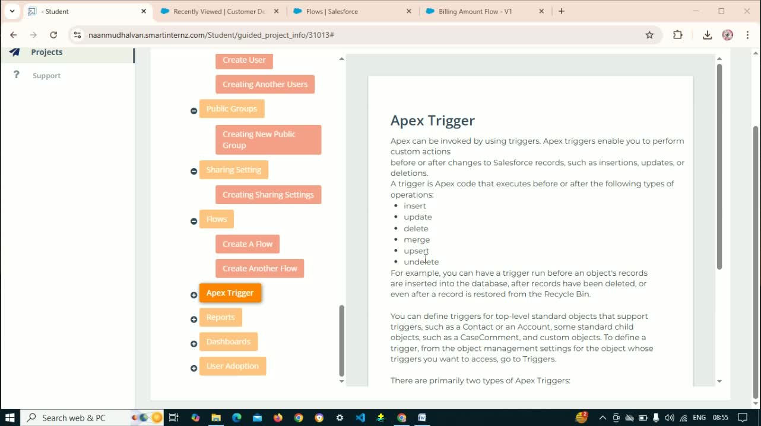

* Implement Apex triggers for operations such as insert, update, delete, and merge.

**14. Creating Reports and Dashboards**

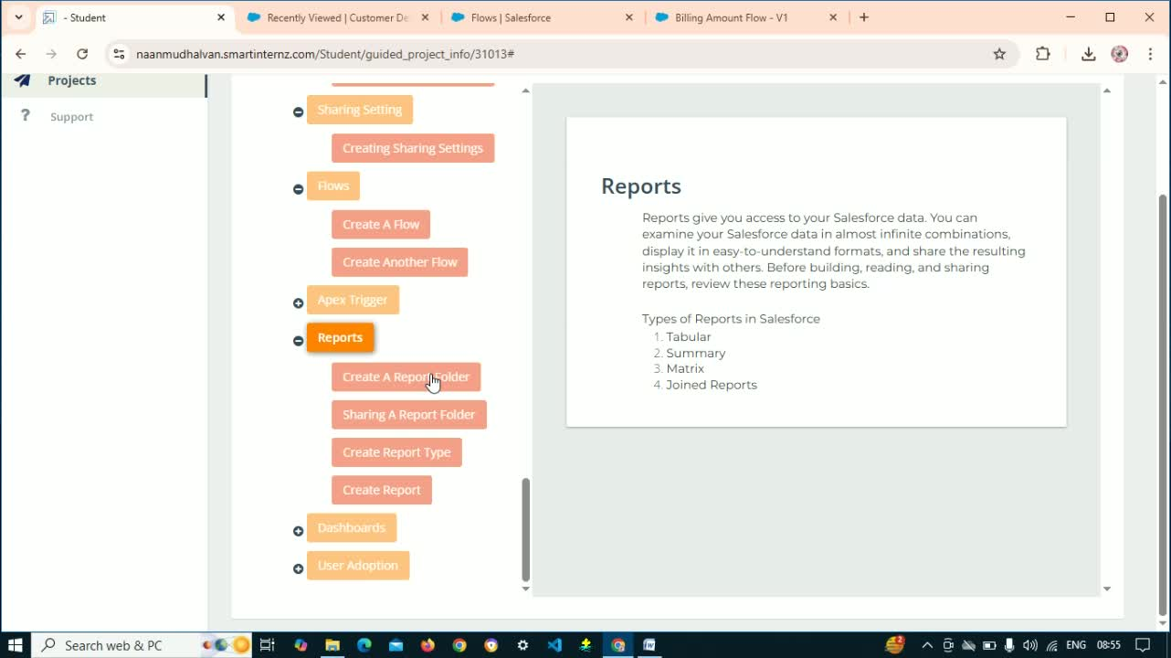

* Create a folder for reports and add a new service information report.
* Create a dashboard folder and a service rating dashboard.

**15. Creating Records**

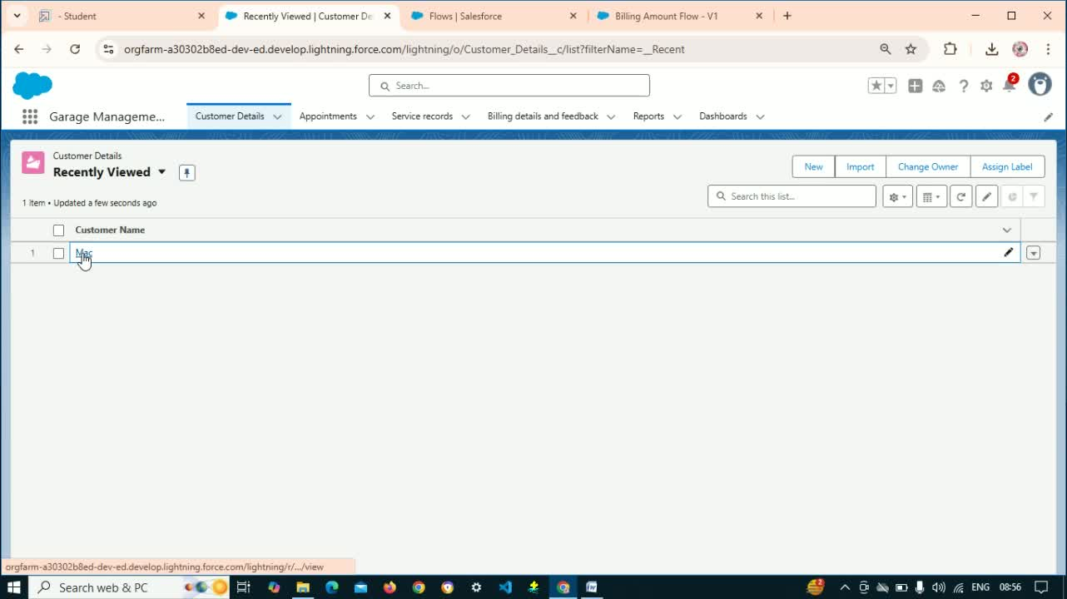

* Create records for:
  + Customer (e.g., Name: Mac, Phone Number)
  + Appointments
  + Service Records
  + Billing Details.

**Cautionary Notes**

* Ensure all custom objects and fields are properly defined before creating relationships.
* Validate all data entries to avoid duplicates and errors.

**Tips for Efficiency**

* Regularly back up your Salesforce data to prevent loss.
* Use templates for reports and dashboards to save time on future projects.
* Document any changes made to the system for future reference.

# Conclusion

The Garage Management System, built on Salesforce CRM, streamlined service bookings, customer management, and payments while delivering insightful reports, automating operations for improved efficiency and customer satisfaction.